Notes for Authors for the Journal of JSEM
247 mm
172 mm

Taro JIKKEN* and Jiro RIKIGAKU**

An example of the manuscript for the Journal of JSEM is shown. **************** ******************* ********** **** ***** ***** **** ** **** ****** ****** ***** *** ****** ***** ********* ****** ***** ** ******* *** **** ****** ****** ***************** ***** ********* **** ****** *** **** ***** ***** ***** ********* **** **** ***** *******.
10 mm
10 mm
Key words: Experimental mechanics, Photoelasticity, Stress concentration, Optical engineering, Digital image processing, *******, **** ******, ******** **

1. Style, Margins and Fonts
a. The title of the paper and the list of authors should be formatted to use the full width of the page. Abstracts and Key words should appear after the authors. The remainder of the paper should be formatted to appear as two columns, with a column width of 82 mm and 8 mm between columns.
b The paper size should be A4 or US letter. The document should be typed in an area of 172 mm × 247 mm.
c. The preferred font is Times Roman. The font of section headings should be Helvetica or equivalent. The title should be 16-point type. The authors: 11pt. The section headings: 10pt. The text: 9pt.

2. Length
2.1 Limit of length
Length of the paper is limited to 8 pages for the Journal of JSEM, including text, illustrations and references.

3. Title
Type this information 2 lines down from top margin in 16-point type and center.

4. Authors
Table 1 Caption of table
Retardation (nm) | Fringe order | Observed color
0 | 0 | Black
400 | 0.73 | Yellow
650 | 1.19 | Blue

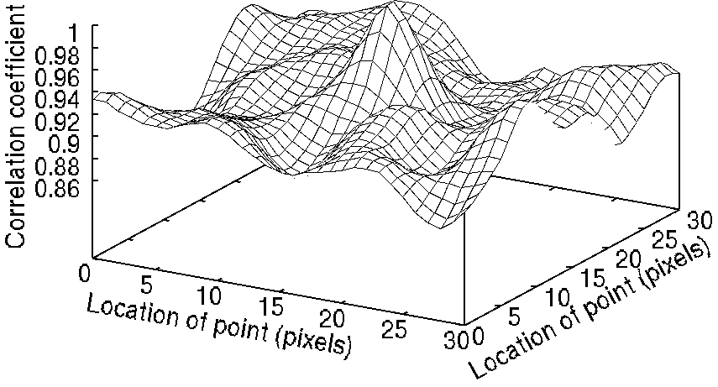
Fig.1 Caption of figure in relation between correlation coefficient and location of point
Type this information centered below the title.

5. Abstract and Key Words
Begin the abstract after the list of authors. Include a short abstract (maximum 200 words) consisting of a one-paragraph summary of the main points of the paper. Include 5 to 8 keywords after the abstract. All text should be single-spaced.

6. Photos and Drawings
a. Photos and line drawings, clearly marked by figure numbers, should be reduced and positioned at the appropriate location within the text. Figures may occupy the full width of the page if necessary.
b. Color photos and drawings are not accepted basically.

7. Equations
Equations must be allowed sufficient space to ensure clarity. Equations must be numbered consecutively, with the numbers parenthesized at the end of the corresponding line.
(1)
Received on August 4, 2017
* Department of Mechanical Engineering, University of Experiment (Komagome, Tokyo 133-8622, Japan)
* * Institute of Optics (Noda, Chiba 278-8510, Japan)

8. References
a. Use superscript notation to indicate the reference number in the text, for example¹⁾.
b. References must be listed by number at the end of the paper.
c. Do not list references which are not cited in the text.
d. References should be prepared in the following general format: author (last name, and initials), title of article, title of publication, volume and issue number, year of publication, page numbers. Font size is 8pt.

References
- Frocht, M. M. and Guernsey, Jr.: Further work on the general three-dimensional photoelastic problem, J. Appl. Mech., 22-6 (1995), 183-189.
- Chao, Y. J. and Sutton, M. A.: Accurate measurement of two- and three-dimensional surface deformations for fracture specimens by computer vision, Experimental Techniques in Fracture (Epstein, J.S ed.), VCH Publishers (1993), 59-93.
- Dally, J. W. and Riley W. F.: Experimental Stress Analysis (3rd ed.), McGraw-Hill (1990), 374-388.
- Yoshida, J., Kumagai, T. and Iguchi M.: Effect of local wettability change on liquid plug length in microgravity (in Japanese), J. JSEM, 4-2 (2004), 25–29.
- Abe, H. and Igata, N.: Ouyou Kinzoku Butsurigaku Jikkenho (in Japanese), Korona Sha (1961), 33-39.
- Blitterswyk, J. V., Fletcher, L. and Pierron, F.: Characterisation of the interlaminar properties of composites at high strain rates: a review, Adv. Exp. Mech., 2 (2017), 3-28.
- Rys, T., Chen, L. and Sankar, B.: Mixed mode fracture toughness of laminated stitched composites, CD-ROM Proc. 2004 SEM X International Congress and Exposition on Experimental and Applied Mechanics (2004).
- Longhurst, W. L.: Force control friction stir welding, PhD Thesis, Vanderbild University, (2009).
- ImageJ download directory: https://imagej.nih.gov/ij/download.html

