Research Paper Title

First AUTHOR¹, Second AUTHOR¹, and Third AUTHOR²

¹Department of XXX, Faculty of XXX, XXX University, Japan

²XXXX Corporation, XXX

E-mail ****@****.***（E-mail address is not mandatory）

A one-page abstract of 300-500 words in English should be submitted from the Workshop website (https://jsem.jp/IWAEM22/). One small figure or table can be included in the abstract, if necessary. The abstract contains the following: 1) title of paper, 2) name, affiliation of the first author, and e-mail address of the corresponding author, 3) names and affiliations of co-authors, if any, 4) background, objective, method, main findings and results including small one figure or table, and 5) about five keywords to describe and categorize your research.
xxxxxxx
xxxxxxx

The abstract must be submitted as a Word document (.doc and .docx are available) by the website. Please change the file name into the first author's full name, e.g. "JikkenRIKIGAKU.docx". The length of the file name should be less than 30 characters. The file size should be less than 3 MBytes.
The abstract should not exceed one page.

Key words: XXX, XXX, XXX, XXX, XXX.

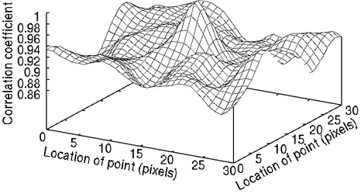

Fig. 1 Figure caption

